NEWSLETTER IMPLEMENTATION PLAN
- About
The project focuses on designing an AI workflow system that allows users to configure link websites AI can search. After config, this workflow enables web searching, selecting and reading relevant articles, and generating many summaries in multiple formats. It is designed to support multi-platform integration, allowing content to be distributed across channels ((including external and internal) such as social media, email, and websites…
- Project Phases & Resource Plan
2.1. Phase & Timeline
2.1.1. Phase 1: Init Project
No | Work | Description
1 | Demo homepage | Present and demonstrate the existing homepage
2 | Set up admin accounts | Create and manage admin accounts for system access
3 | Set up the main system | Prepare and configure the main system for use
4 | Arrange data backup | Set up a process to regularly back up data
5 | Build work processes | Design and organize team workflows
6 | Collect information from each department | Gather necessary information from all departments
7 | Demo version 1 | Deliver and present the first demo version
In this phase, AI teams focus on identifying problems, setting up servers and writing the business requirements document. Note: API key required for the demo version
2.1.2. Phase 2: Delivery Production
No | Work | Description
1 | Customize internal Newsletter | Adjust the newsletter to fit internal needs
2 | Integrate API workflows into Newsletter | Connect different system processes into the newsletter
3 | Edit and refine workflows | Review and improve existing workflows
4 | Customize navigation | Improve how users navigate the system
5 | Go live production | Launch the system for official use
In this phase, teams focus on customizing the system, integrating workflows, improving user experience, and preparing for the official launch.
2.1.3. Timeline
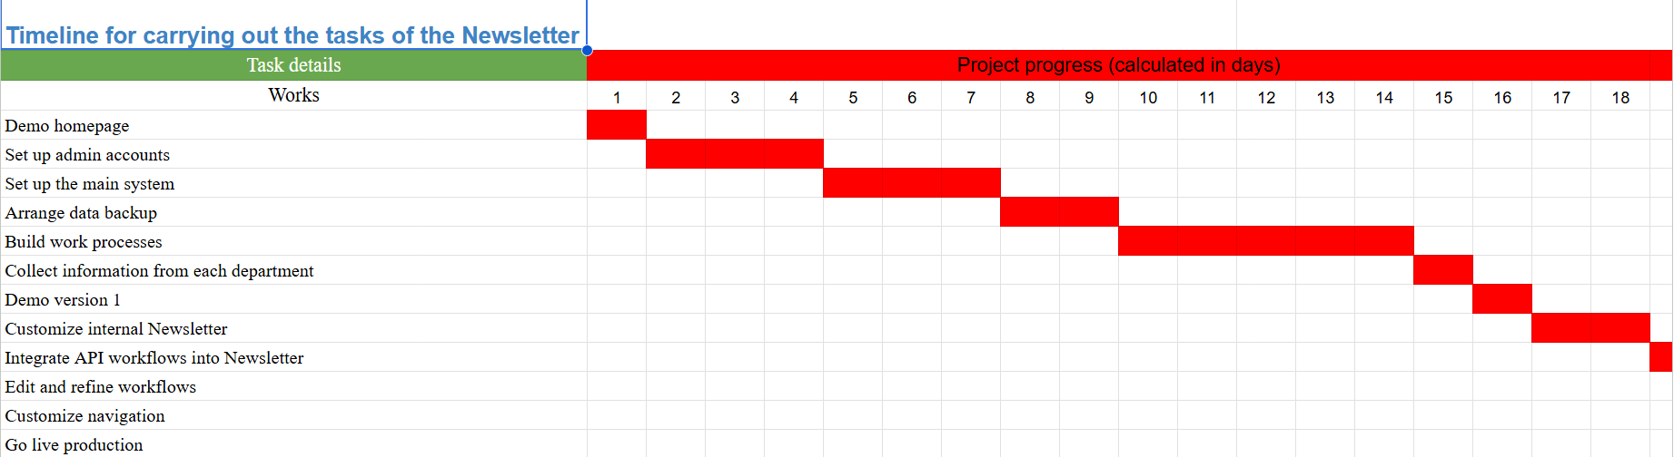
This timeline summarizes the key project activities, milestones, and overall progress.
Link to detailed timeline
2.2: Staffing Plan
No | Position | Name | Responsibilities
1 | Project Manager/ AI Engineer | Tran Bao Ngoc | Oversee project progress, coordinate between teams, and ensure timely delivery
2 | Fullstack Developer/DevOps | Do Trong Tan | Integrate API into many platforms, channels.
3 | Intern AI Engineer | Nguyen Hoang Vinh | Execute workflow automation as the AI Engineer requires.
3. Cost/Budget
3.1. Demo Cost
No | Tools | Cost | Description
1 | Server | 0 | The current server meets the requirements for service deployment
2 | OpenRouter API Key | Minimum $20/month | We recommend a budget of around $20/month for the development phase.
After completing phase 1, the AI team will provide a report on token usage to help optimize costs and plan for production in phase 2.

